FREE Architectural or Real Estate Rendering.
Introducing VIEWZZ Architectural and Real Estate 3d Visualization.
This is an image I received for FREE on one of my current designs to help sell some real estate. All I supplied VIEWZZ was a Sketchup model and minimum direction. All VIEWZZ profits go to charity. I was so impressed with their service that I decided to help promote their Company.
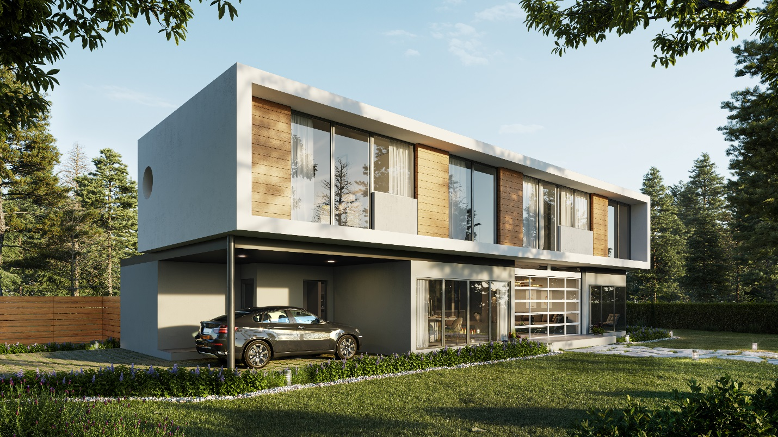

PROMOTIONAL PRICING: Get your FREE Rendered image on your existing projects to grow our client base and prove our worth to you. No obligation, quick turn-around. Perfect for Developers, Real Estate Agents, Architects, Builders and marketing agencies, Presales or Portfolio projects.
If you don’t have any previous projects, but still want to try our service – We will work for you for 6 months at half our regular rate to gain your business.

About VIEWZZ: https://www.viewzz-studio.com/about-us
About REACH – Feel good about making a difference https://reach.org.vn/
About RE-VOLVE / Michael Pearce: Background in Architecture, Real Estate Investments, Development and 3d design RESUME
Regular Pricing: REGULAR PRICING
VIEWZZ Studio Portfolio: https://www.viewzz-studio.com/home

Please contact me for more information or to give us a try. INFO@REVOLVELLC.COM
Our end objective is to help more people help themselves. Please forward this to anyone you know that might be interested.
Michael Pearce

